Shenzhen Juntong Technology Co., LTD |  | Document  Number | Version  number | Classificati  on level
 |  | 202512171536 | V1.0 | External  Public
Document  Name | Full-Color Display Development Manual |  | Date | 2002-12-17

Full-Color Display Development Manual


All rights reserved by Shenzhen Juntong Technology Co., LTD

Document Revision Record

Versio n Number | Change (+/-) instructions | Date
V1.0 | Create | 2025-12-25

Catalogue

DOCUMENT REVISION RECORD 2
CATALOGUES 3
- INTRODUCTION 5
  - Purpose of the document 5
  - Scope of application 5
- EQUIPMENT OVERVIEW 6
  - Equipment Introduction 6
  - Power Supply requirements 7
- QUICK START GUIDE 7
  - Bluetooth Debugging 7
    - Device information 7
    - Hardware preparation 8
    - Software preparation 9
    - Debugging steps 9
  - Serial communication 11
    - Hardware preparation 11
    - Software preparation 12
    - Hardware connection 13
    - Serial port testing 14
- INTERACTION PROTOCOL 16
- SAMPLE PROGRAM 16
  - Feature Overview 17
  - Basic Usage 17
    - Code acquisition 17
    - Directory Structure description 18
  - Compile and Run 18
  - Sample program instructions 18
    - IOS & Android 18
    - Windows instructions 19
    - MCU instructions 20
  - Precautions 20
  - Update instructions 21
- FREQUENTLY ASKED QUESTIONS FOR TROUBLESHOOTING 21
- FEEDBACK AND SUGGESTIONS ON ISSUES 21

Introduction
  - Document Purposes
This document is intended to provide a systematic description of secondary development for full-color display screens, helping users and developers quickly understand and use the hardware, protocols, and multi-platform sample software provided by this project.

With this instruction document, readers can:
- Properly connect the flexible display to the external control device
- Control the flexible display using sample programs provided for MCU, Windows, iOS, and Android platforms
- Develop or integrate other control systems based on publicly available communication protocols

Scope of Application
This document is for the following persons:

Application software developers
A developer who uses Windows, iOS, or Android platforms and controls the content or behavior of flexible displays according to communication protocols.

System integration engineer
Engineers who need to integrate flexible display screens into existing systems or products and control them through protocols.

Embedded systems developer (control end)
Developers who implement communication protocols on external MCUS, master boards, or other control devices to interact with flexible displays.

Product development and technical support personnel
People who need to know about flexible display interfaces, communication methods, and basic usage methods.

Equipment Overview

Equipment Introduction
Full-color flexible display screen, with a flexible screen and drip glue process, can be directly pasted, lightweight and easy to install. It supports mobile APP and remote control. The mobile APP can set functions such as text, animation, doodle, music rhythm, etc. It can be used in the following scenarios:
- In-vehicle applications

- Window display glass
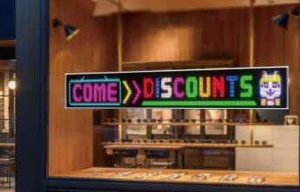
- Storefront application
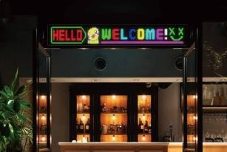

- Devil's Eye App

- Creative apps


Power Supply requirements
The display supply requires DC-5V. Do not use the voltage beyond the range, otherwise the device will not work properly or even be damaged.
Note: Different resolutions of displays may have different power requirements. Please refer to the display specification sheet.

Quick Start Guide

Bluetooth Debugging
The flexible screen products mentioned in this document use Bluetooth, which is the Bluetooth Low Energy (BLE) protocol available only in versions 4.0 and above.

Device Information
- Device Name
CoolLEDUX, JotuPix

- Bluetooth Service UUID and eigenvalue UUID
Basic UUID: 0x0000xxxx-0000-1000-8000-00805F9B34FB
Bluetooth service UUID: 0xFFF0
The Bluetooth eigenvalue UUID is: 0xFFF1

- Device ID
The device ID is located in the first and second bytes after the Manufacturer Specific Data in BLE broadcast data, totaling two bytes. For example, data FF0F00. Where FF is Manufacturer Specific Data (manufacturer-specific data), 000F is the device ID, with the lower byte first and the higher byte second. The data in the red box in the following figure.
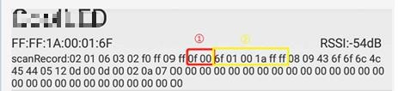

- Device MAC address
Since IOS cannot obtain MAC addresses directly through the system interface, the MAC address of the device is also located in the third to eighth bytes after the Manufacturer Specific Data in BLE broadcast data, totaling six bytes. The data in the yellow box in the following figure. FFFF1A00016F is the MAC address, with the lower byte in front and the higher byte behind.
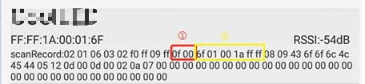

Hardware preparation
- A set of flexible display screens

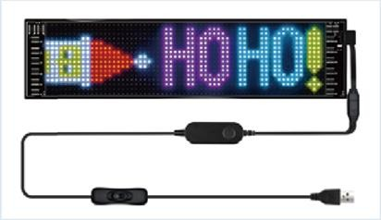

- One mobile phone or tablet.

Software preparation
BLE Debug Assistant APP One. Here the iPhone app "Lightblue" is used as an illustration, and Android phones can choose the corresponding BLE Debug Assistant.
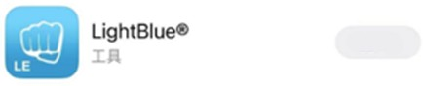
Open

Debugging Steps
- Power the flexible display, and if it's a USB-powered version, try to power it with a phone charger of 5V/2A or more.
- Open the BLE debugging software and click on the device name to connect. The device name is CoolLEDUX.
- After the connection is successful, select the service ID with UUID 0xFFF0 and the feature ID with UUID 0xFFF1 for communication.

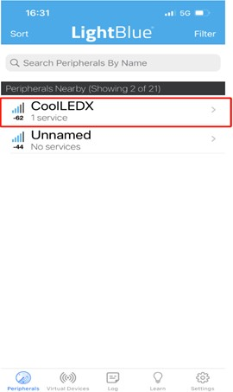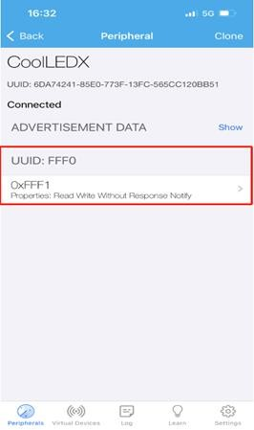

- After connecting the UUID, enter the data sending interface. The data sending format is HEX. Click "Write new value" as shown in the figure.
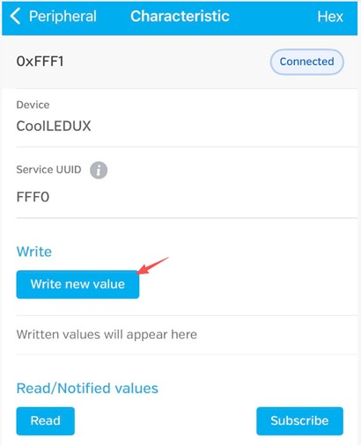

- Enter the sample instruction and click Send.
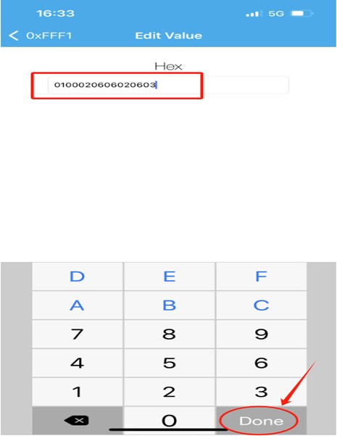

Sample instructions (in hexadecimal) :
Turn on the screen: 0100020605020503 Screen off: 01000206050003

  - Serial port communication
The serial port uses bidirectional communication mode, serial port baud rate: 400,000, 1 stop bit, 8 data bits, no parity.
If control is not possible, swap RX and TX.

    - Hardware readiness
- One flexible display screen

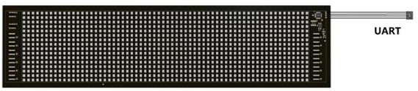

- Usb-to-ttl serial port clipboard
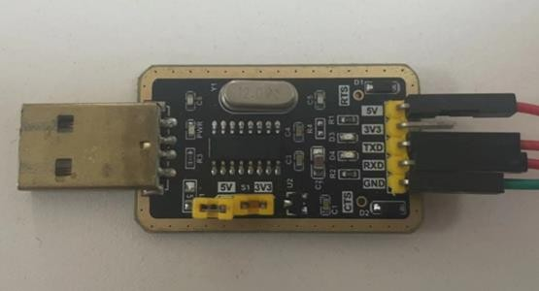

Or use UART to RS232:

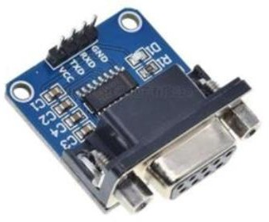 | 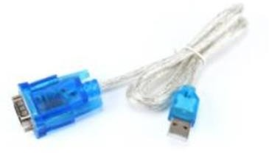
UART to RS232 serial clipboard | USB to serial cable

Software preparation
Serial Port Debugging Assistant, which can be downloaded from the Internet, any available one will do.

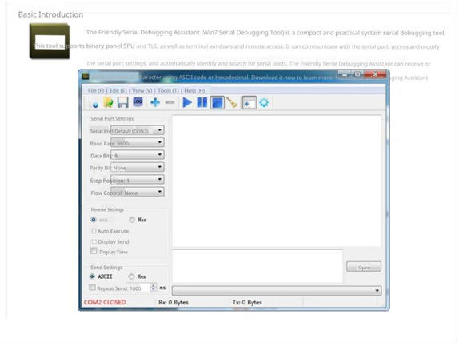

Hardware connection
Connect the aforementioned hardware devices according to the basic electrical characteristics of serial port connections, namely RX->TX, TX->RX. And lead out the power supply line, either an external USB cable or a DC regulated power supply of 5V.
Do not connect the power cord in reverse!

Flexible display screen
Upper computer or serial porttool

If your computer's USB power is insufficient, you need an external power supply. The external power supply is connected as follows:

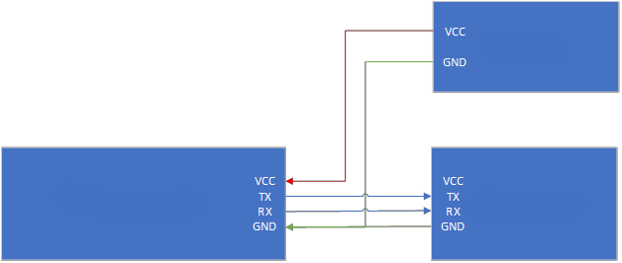
external power supply
Flexible display screen
Upper computer or serial port tool

    - Serial port test
- After the connection is successful, turn on your computer and go to "Computer" -> "Device Manager" -> "Port" to view the serial number.
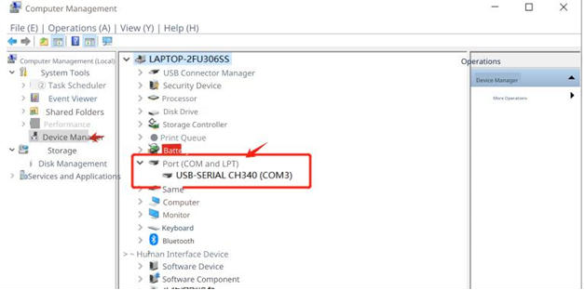
- Open the Serial Port Debug Assistant, select the corresponding serial port number, baud rate 400000, data bit 8, check bit None, stop bit 1, flow control None. Both the receive setting and the send setting are Hex.

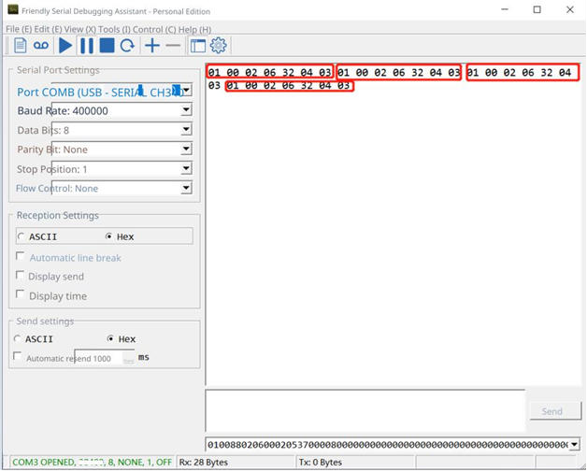

Note: After opening the serial port, you will receive a power-on command from the device. Ignore it.

- Send startup instructions to test the device. Type: 0100020623020503 (hexadecimal) in the serial tool send box, and the device will boot up, display the ID, and then show the preset content.

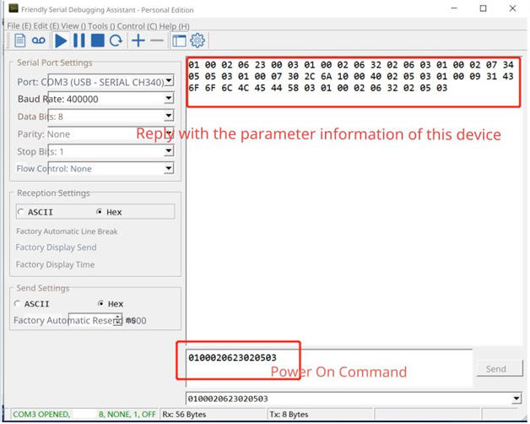

Sample instruction (hexadecimal format) : Turn on the screen: 0100020605020503 Screen off: 01000206050003

Interaction Protocol
For the interaction protocol, please refer to the documentation "Interaction Protocol for Secondary Development of Full-Color Display Screens"

Sample Program
The sample program is licensed under the MIT Open Source LICENSE. See the License file in the project for details.

The sample programs related to this project are uniformly hosted in the following code repositories:
https://github.com/jotupix/demo

Feature Overview
The sample program provides for demonstrating how to control and modify content on a flexible display through an interactive protocol.

The sample program is primarily used as a reference implementation to help developers quickly understand the communication process, data organization, and control logic implementation, and to provide a basic code reference for secondary development, enabling the rapid construction of a runnable project.

The sample program mainly has the following functions:
- Data transformation and parsing
- Data subcontracting sent
- Data compression processing
- Program data construction
- Basic instructions and program sending
- Provide a basic operation interface for testing and validating control functions
- Scan and connect the flexible screen device

Basic Usage

Code acquisition
Clone the code repository using the GIT tool
git clone https://github.com/jotupix/demo.git
When the clone is completed, the code repository will contain directories of iOS, Android, Windows, MCU and related sample code.

Directory Structure description
The directory structure of the sample program in the code repository is as follows:

JotuPix/
├── doc/ # documentation
├── ios/ # iOS sample program
├── android/ # Android sample program
├── windows/ # windows Sample program
└ -- mcu/ # mcu examples such as stm32, esp32

Compile and run
For details, see the "README" of the sample program in each platform directory.

Sample Program Instructions

IOS & Android
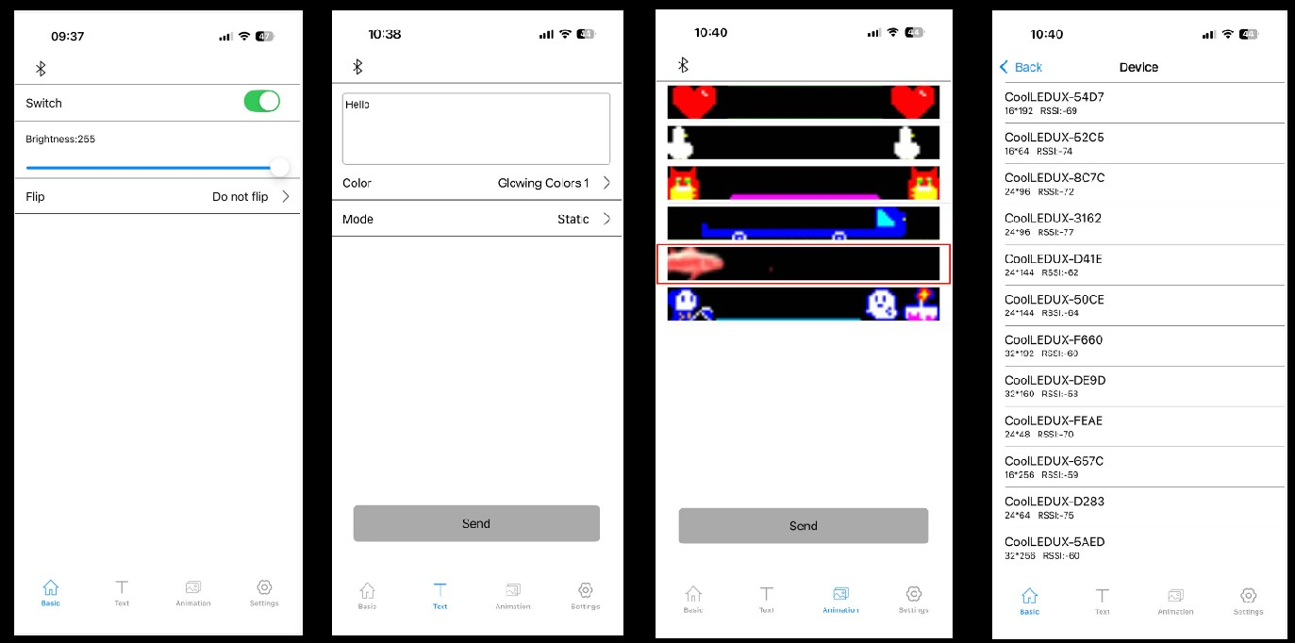

      - Basic Features Page
This page mainly provides examples of some basic functions such as: turning devices on and off, adjusting device brightness, setting device flip status.

      - Text Features Page
This page provides basic Settings for displaying text on the screen. You can type in any text and send it to the device for display. And offer the ability to select text color and display mode.

      - Animation Function page
This page provides examples of the feature to display GIF animations, with several built-in GIF sample animations that can be sent to the device for display.

      - Device List page
This page can search for display devices using BLE and make device connections.

Windows Instructions
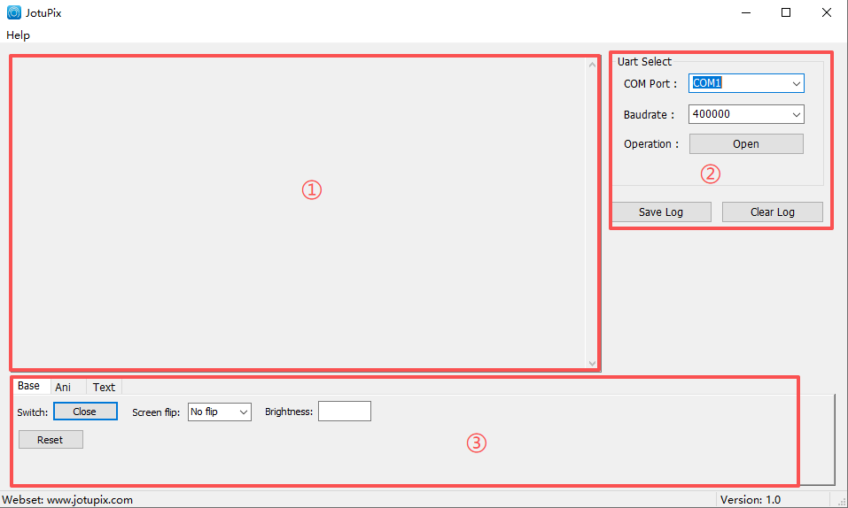

We provide Windows sample programs that communicate with devices via serial port and control device functions.
The Windows sample program interface is mainly divided into three parts: the log output area, the serial port configuration area, and the functionality area.

      - Log Output Area
This area provides program log output functionality. Runtime data and error prompts are output to this area, and the data from this section can be used for comparison during development.

      - Serial port configuration area

This area allows you to select serial numbers, configure serial baud rates, and connect and disconnect serial ports.
      - Ribbon
This area provides examples of various features of the display device, such as: turning on/off, adjusting brightness, configuring flip, sending GIF animations, sending text, etc.

    - MCU Description
We provide an STM32 host computer sample program to operate and control the device via serial port.

The following features are provided: doodle, animation, border, glitter text, custom color text, GIF animation demonstration.
Each demonstration function is automatically switched every 5 seconds.

  - Notes
The IOS & Android sample program relies on BLE to communicate with the device. Windows & MCU sample programs rely on serial ports to communicate with devices.

The sample program is just a demonstration of the relevant functions of our display screen. If you need to use the actual project, please modify the open-source code yourself.

Update Instructions
We will update the sample program from time to time for new feature demonstrations. Please keep an eye on our code repository address or website.

Website: www.jotupix.com
Warehouse address: https://github.com/jotupix/demo

Frequently
Asked questions
for troubleshooting

- Issue feedback and suggestions
If you have any comments, suggestions or need assistance with our products, please contact us by email.
Technical support: jotupix.tech@gmail.com

If you have any needs for product purchase or customized development, please contact us by email.
Sales: jotupix.sales@gmail.com

